

Dear Canadians, We Are Making An Announcement For the World Today!

Today, as of Wednesday 28, 2025  
We are officially declaring the end to Donald Trump’s Trade Tariff Wars, TM officially over and he will cease fire immediately!  
  
Because CANADA just won the war for the world! #ElbowsUp  
  
The Royal Canadian Armed Forces through their secret-special operationalist reserve. ME Evan, Svendsen! Have identified an immediate threat that the world must be informed of. The reckless actions of both the CEO of Disney Bob Iger & The President of The United States Donald Trump. Have created an inevitable series of chain reaction events that will propagate across this globe causing the next great depression in every nation on earth EXCEPT America & ITS allies. And since a **Canadian** citizen diffused the bomb, you are really going to want to hear about how we did it. Because WE (The World + Canada) will be winning the war. And we dictate the terms of this agreement.

Through telling stories. What does Disney sell? STORIES! And we will have 100+ years OR more of them when Disney builds our new Disneyland Canada theme park south of Calgary, Alberta. Because this new one built here in Canada will be the only one incentivized by HUMANITARIAN aid efforts worldwide. 35% of all proceeds once open will go towards humanitarian aide effort worldwide. Because CANADA just created a STORY that is so incredibly profound. That when you, here it you may all end up believing in God himself.   
  
Therefore, our new Pope will love it because it will double his church size,

And it’s already reached the desk of **His Majesty** the King 👑 who just happens to be here in Canada right now. With Danielle Smith, our fabulous  
  
Because Donald Trump your entire military failed!

You did not calculate that an ECONOMICS and TECHNOLOGY development conference planned by our Honorable Mayor to the City of Calgary, Alberta. Already planned this LAST YEAR! YOU SUCK!

This was the most influential conference this city has had. So much that DURING an ECONOMICS WAR you let a United States Citizen named Garry Vee cross the boarder into Canada to meet with us. CANADIANS!

And through ideation with over 900+ of the smartest minds in the planet and the world. We have found the **ONLY** solution in existence that will prevent the next world war! Because Bob Iger just built a **NUCLEAR BOMB** and the process of the chain reaction is already unfolding as we negotiate. The number one cause of every revolution and

FOOD BANKS, **FOOD BANKS** are failing in **CANADA. We are a third world nation here. When the World’s number one supplier of humanitarian aid & disaster relief worldwide goes bankrupt?** What happens to… everyone else?  
  
We are announcing today that American’s are **Monkeys** with nuclear warheads. Not one of them is smart enough to understand what happens if the largest **employer** on this planet goes bankrupt. Because….. “Disney went woke.”  
  
Because the only one with a deep and profound knowledge of all this:

Arab Spring, Nuclear Physics, Economy (conservative issues), LGBT Issues (liberal issues), Politics + Riots, Warfare + Military, Ayn Rand, Business, Math, Statistics, Software, Failed States + Communism, Propaganda, International Treaty's + the UN, Real Estate + Taxes, Advertising & Marketing, History!

Is ME! I just got a 4.0 GPA. Which makes me the smartest person in the room here. And that’s part of the story which is HILLARIOUS. I’ve been trying to find a job to sponsor me to go down there to the USA for over 10 years. But it’s not the USA I love it’s the ability for innovation to occur. How did none of you expect what would come from 900+ brilliant minds from across out country to come up with?

And this is a TRILLION-dollar business model for Canada, that will get our wonderful new Prime Minister the Honorable Mark Carney his 100M new residents, and jobs for **ALL**, of our new immigrant friends. Because we don’t need anymore of them working for

**Walmart**! A corrupted **American,** corporation. Right now, the whole world (mostly) hates them.   
  
Humanitarian aide effort worldwide should not cost TAX-PAYER MONEY when disaster relief efforts worldwide is a **TRILLION,** dollar economic machine for our country. China will thank us for saving them TRILLIONS of dollars lost in their economy when all manufacturing of Disney branded product ceases to a haul next month during Pride MARCH!  
  
Bob Iger do you even know who makes your PRODUCT that you sell? China…  
They also have a theme park too that was liable to go under. You are very Welcome, Xi Jinping.  
  
Because Disney is the number one employer on this planet. But Americans are too stupid to understand how their own economy works. The ONLY thing extracting our resources out of this country exponentially. To yours. Disney! Canadians are PISSED OFF that you gave the contract to the UAE. They have more money that YOU they have more money than GOD! The meme is that they wipe their asses with toilet paper. Do you know how LITTLE money it would take to fix our infrastructure? And to the Canadians who don’t understand MATH?

And this is why the plan going forward comes directly from God himself. Because the guy that just fixed all of the world’s problems at once. Was someone God designed to be brilliant at math because he loves Monopoly.  
  
The city that hosted the Indentures Tech & Economic Development Conference in Calgary Alberta. Is just 1 hour north of where he was born. In the town of Didsbury, Alberta. Further; the site of our Disney theme park will be located around the area where his grandparents are buried in the town of Blackie, Alberta.  
  
This new Winter Wonderland Themed **FROZEN** IP branded theme park built 1 hour south of Calgary Alberta, On historic Indigenous land with the worlds largest authentic Tee Pee Village where the Indigenous of our nation will be employed to work for Disney.

Because Disney tells stories and these people LOVE telling you there’s. Only they have never been able to do so with a BILLION-dollar budget for a major Hollywood film studio. To the kind folks up in Edmonton, Alberta who just lost their jobs working for Bio Ware when it collapsed 4 months ago.  
  
Why have there never been any major AAA game studios in Alberta? A city that has pledged for over 25 years they would be the worlds next center of innovation and tech. Because there isn’t a DISNEY anywhere within 3000 miles. And TOURISM is the only thing not contributing to our GDP. Canadians, Americans Does ANYONE understand math? AT ALL?  
  
Because the guy that just figured all the pieces of the equation out. Got a medal in high school for a Finance course and just finished the equation. And the only reason he loves math is because his dearly passed grade 1 teacher Harley A. Dickinson taught it to him & his favorite board game is Monopoly MONEY.



You people make fun of us because we are Canadians. We LOVE it up here!!!! WOOOOOOO  
We are children in this country because Harley Road the shopping cart down the isles of Walmart saying “WEEEEEEEEE!” and he would dance on the tables in the classroom singing the beach boys every day.  
  
And Harley a grade 1 teacher in one of the most insignificant towns in this nation economically. Is where the guy who just diffused the bomb was born. Harley; just happens to be the ex-husband of Alene Dickinson, and when she found out Canadians are rooting for our banks to collapse. She was pretty pissed.  
  
So we crafted her the best pitch ever:  
  
If Disney builds this new (budget already planned) theme park here in CANADA instead of the UAE, then Canada will build a world class facility & school for training in disaster relief using 25% (negotiable) of its proceeds in perpetuity!!   
  
And immigrants to our new glorious nation will get to chose to enter a world class training facility for Disaster Relief which will be funded with 12 Billion dollars worth of Disney infrastructure into our nation. Canada will also demand 12 Billion EACH to humanitarian efforts for the kind folk in Ukraine, Gaza, and Israel. So long as an immediate cease fire worldwide begins starting now for negotiations.  
  
Russia & Putin if you comply then Canada will ensure world peace globally including you. Because we are ENDLESSLY empathetic up here. And we can negotiate a separate contract later. Separately because we will not stand for Omnibus bills that pledge 16 billion promises to people you can’t fulfil on.

Because we only need a few promises to be made and kept and global peace will ensue.  
Tim Pool will be getting a 100-million dollar construction and INFASTRUCTURE projects to construct the worlds largest skate park and his new film production studio in

Alberta because Alberta is where a gay cowboy movie was filmed called broke back mountain in the town of Blackie Alberta. A GAY Cowboy movie was filmed whose target demographic was US. Albertans. And MY OWN UNCLE Terry who lives in your state of Texas owns a quantic in this town that he pays taxes to keep. It was used as a backdrop for this Gay cowboy movie and DISNEY is about to have a very big problem with

this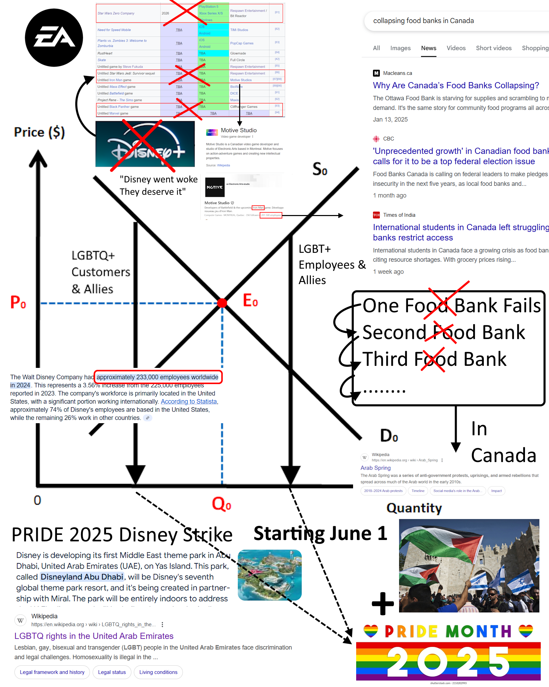

And gay people do not want to make PRODUCT for people who KILL THEM!

This strike will put millions of people on this planet out of a job.

But Americans are so bad with their own money they think that Disney “Only contributes to 10% of their economy!”

I wonder how many hotels, restaurant workers, gift shop owners, retail shopping malls, other theme park attractions, within a 300 mile radius of any Disney theme park would feel to hear about that information.

Because TOURISM and INFASTRUCTURE are failing. So Our Kind & Honorable Mayor for the City of Calgary where this construction will occur "Jyoti" Gondek. Will be getting 300 million dollars from our currently allocated budget for infrastructure across the city. and she is the most brilliant woman in the country. That she scheduled this economics conference in Calgary last year. And Trump started a war with us all 4 months ago. Exact same time the ONLY significant game developer studio in the province BioWare collapsed.  
  
Well Garry Vee if you want incentive structure to come up to Canada?  
Disney’s family branded values are hereby revoked until these demands are met, because driving home from this conference I passed an entire family through Claresholm Alberta that had died is the most brutal accident I have ever seen in my entire life. If the families of this community are wondering, why their loved ones passed away?  
  
Disney no loner understands family because the UN needs to open a full audit into these parent’s they are BRUTALIZING their children with discipline so severe some almost died

Family Incentive: All residents of the town of Claresholm and their FAMILY’s and any other family affected by this entire family dying. Will be getting free lifetime passes to our Disney park as well as their friends & neighbors in every other small community between the stretch on the road up to Nanton will be getting them too.  
  
Because Nanton is going to receive 84 million dollars worth of infrastructure to The Nanton Air Museum & one of the only remaining Lancasters in the world sit. And the worlds largest aviation museum in the world to teach our entire history of Aviation in Canada.

Because that’s a STORY that Americans never thought of themselves. They don’t tour to our country based on a statistical survey conducted this week following this conference found of respondents who are American citizens:  
When asked the question “Have you visited Canada before” exactly 0% of them answered YES!  
  
And the reason this is all going to BE DELIVERED ON WE PROMISE is because America could have stopped it if they just gave me a visa

But they didn’t want my talent ahaha. So I will be selling my brand new game that looks like Monopoly but plays very different. At the Games Con Canada convention in Edmonton which is now the largest gaming convention in the world. Because I cant AFFORD to spend $10,000 USD to come to Pax West or Pax East

Tourism!!! Folks we need tourism!!! DISNEY IS MONEY!!!!

And our postal strikers are about to go on strike at the same time as your GAY employees do as well. Mr Trump why did you not mention to our new prime minister that Disney was in negotiations for this contract already?

Their number one request was money,

An addition survey of residents in the local community found that of everyone’s problems they are trying to solve. The root cause is money.

To the people of Gaza & Ukraine. If you stop waring in our streets with this peace agreement. We will train you to handle disaster relief back in your home country. And you will be able to save